SmartPlant 3D
Drawings Training Exercises



Version 6.0 | September 2005

Copyright
Copyright © 2004 Intergraph Corporation. All Rights Reserved.
Including software, file formats, and audiovisual displays; may be used pursuant to applicable software license agreement; contains confidential and proprietary information of Intergraph and/or third parties which is protected by copyright law, trade secret law, and international treaty, and may not be provided or otherwise made available without proper authorization.
Restricted Rights Legend
Use, duplication, or disclosure by the Government is subject to restrictions as set forth in subparagraph (c) of the Contractor Rights in Technical Data clause at DFARS 252.227-7013, subparagraph (b) of the Rights in Computer Software or Computer Software Documentation clause at DFARS 252.227-7014, subparagraphs (b)(1) and (2) of the License clause at DFARS 252.227-7015, or subparagraphs (c) (1) and (2) of Commercial Computer Software---Restricted Rights at 48 CFR 52.227-19, as applicable.
Unpublished---rights reserved under the copyright laws of the United States.
Intergraph Corporation
Huntsville, Alabama 35894-0001
Warranties and Liabilities
All warranties given by Intergraph Corporation about equipment or software are set forth in your purchase contract, and nothing stated in, or implied by, this document or its contents shall be considered or deemed a modification or amendment of such warranties. Intergraph believes the information in this publication is accurate as of its publication date.
The information and the software discussed in this document are subject to change without notice and are subject to applicable technical product descriptions. Intergraph Corporation is not responsible for any error that may appear in this document.
The software discussed in this document is furnished under a license and may be used or copied only in accordance with the terms of this license.
No responsibility is assumed by Intergraph for the use or reliability of software on equipment that is not supplied by Intergraph or its affiliated companies. THE USER OF THE SOFTWARE IS EXPECTED TO MAKE THE FINAL EVALUATION AS TO THE USEFULNESS OF THE SOFTWARE IN HIS OWN ENVIRONMENT.
Trademarks
Intergraph, the Intergraph logo, SmartSketch, FrameWorks, SmartPlant, INtools, MARIAN, and PDS are registered trademarks of Intergraph Corporation. Microsoft and Windows are registered trademarks of Microsoft Corporation. MicroStation is a registered trademark of Bentley Systems, Inc. ISOGEN is a registered trademark of Alias Limited. Other brands and product names are trademarks of their respective owners.
Table of Contents
Overview 1
Drawings Task Configuration 2
Setting up for batch process 2
Setting up the Error Log 2
Enable Excel to run Embedded Reports 2
Volume Drawings Workflow 3
A. Adding Piping Plan Drawing 3
B. Placing the drawing volumes 3
C. Updating the documents 4
Snapshot Drawings Workflow 5
A. Creating Snapshot Drawing Type 5
B. Creating a Default View Style 5
C. Snapshot the views 5
D. Composing the drawing 5
E. Updating the documents 6
Drawings by Query Workflow 7
Microstation 3D DGN Workflow 9
3D Model Data (SmartPlant Review) Workflow 11
Setting Drawing Properties 12
Drawings Editor (SmartSketch) Basics 14
Where to find Drawings Editor inside SmartPlant 3D 14
Background and working sheets 14
File – Properties – Units 15
File – Sheet Setup 15
Print setup 16
Pin point for accurate drawing 17
Relationships 18
Format Line 19
Format Dimension 20
Layers 21
Dimensioning 21
Detail view 22
Align elements 24
Symbol creation 24
Placing manual annotation 27
A. Manual labeling 27
B. Dimensioning 27
C. User Text 28
Editing Border Templates 30
Creating New Template 30
Using a DWG/DGN template to seed a drawing template 31
Using an Existing Template as a Background Sheet 32
Adding Drawing Property Labels 32
Basic View Styles 34
Creating a volume view style 34
Creating a snapshot view style 35
Creating a key plan view style 36
Creating a volume drawing package 39
A. Creating the package 39
B. Testing the package 41
Defining Line Styles 43
Graphic Rules 45
VHL Rule 45
Replace with Line Rule 46
Replace with Line and Widget 46
Replace object with symbol 47
Defining Drawing Labels 49
Label Template 49
Label Symbol File 51
Label XML File 52
Creating Label Rule 53
Custom Graphic Rules 54
CappedNormalPipe.dll 54
DesignEquipmentPartSeparator.dll 54
ElbowtoArc.dll 55
ElbowtoSingleArc.dll 56
EquipmentNozzleSeparator.dll 57
GridlinesDrawingWrapperEntity.dll 57
MakeDrawable.dll 57
PipeTurnFeattoArc.dll 58
PortsSeparator.dll 59
ReplaceWPoint.dll 59
SlopedPipeWArcSymbol.dll 60
VolumeWireFrame.dll 60
Advanced View Styles 61
Deconstructing the piping plan view style 61
Analysis of drawings for view style creation 61

Overview
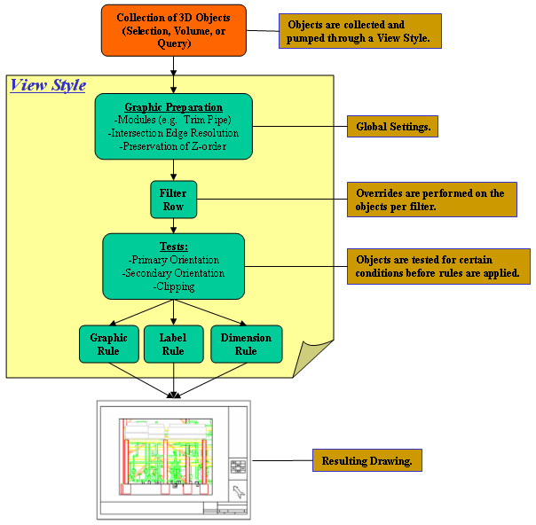

Drawings Task Configuration

Setting up for batch process
Enabling the Microsoft Message Queueing Service

Setting up the Error Log
Edit Registry key
HKEY_LOCAL_MACHINE\SOFTWARE\Intergraph\Applications\Environments\Drawings\ErrorLog and set the Level value to 300

Enable Excel to run Embedded Reports
If Excel 2000, make sure SP3 is loaded
If Excel XP or Excel 2003, check the box under Tools – Macro – Security – Trusted Publishers – Trusted Publishers for Trust access to Visual Basic Project
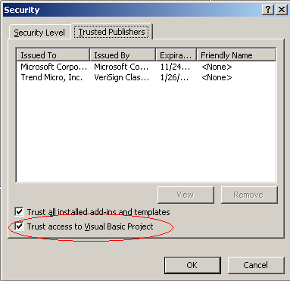

Volume Drawings Workflow

A. Adding Piping Plan Drawing
- Define workspace to by Unit 1
- Switch to Drawings and Reports task
- Right mouse on the Plant and right mouse select New…
- In the Add Component Dialog, from the General tab, select Folder and click OK.
- Select the newly created folder and rename it to ‘GA Drawings’
- Right mouse on the GA Drawings folder under the Plant and right mouse select New…
- In the Add Component Dialog, from the Imperial Drawing Types tab, select Piping Plan

B. Placing the drawing volumes
- Switch to the Space Management task.
- Format – Surface Style Rules and add the rule called Named Spaces to the workspace.
- Open two graphics views and orient them looking down and looking north.
- Start pin-point.
- Start the Place Drawing Volume by View command 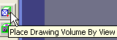
- In the ribbon bar, select Piping Plan for the drawing type
- In the pin-point toolbar, enter coordinates: E: 72’, N -2’, El –3’
- Click in the graphic view once.
- Enter Elevation El 31’
- Click to place the volume.
- Place a second volume by entering pinpoint coordinates E: 72’, N 32’ 6”. El –3’
- Click in graphic view.
- Enter Elevation EL 31’
- Click to place the second volume adjacent to the first one.
- Switch to the space tab of the workspace explorer to see that the two drawing volume are created under the hierarchy of the drawing folders.

C. Updating the documents
- Switch to the Drawings and Reports task.
- Expand the tree to GA Drawings – Piping Plan and right mouse on Piping Plan
- Select Create Drawings
- Two drawings are created, select the first one and update. This takes a couple of minutes.
- Open drawing to view it.

Snapshot Drawings Workflow

A. Creating Snapshot Drawing Type
- Right mouse on the GA Drawings folder under the Plant and right mouse select New…
- In the Add Component Dialog, from the General tab, select New Snapshot Drawings
- Rename the newly created drawing type to ‘Snapshot’

B. Creating a Default View Style
1. Select Tools – Define View Style
2. Select New
3. Enter Default for the name of the Snapshot View Style and click OK.

C. Snapshot the views
  - Switch to the Common task and define workspace to be Unit1. Refresh your workspace
  - Clip the view to all elements using clip by object command
  - Set the 3D view orientation to plan and fit the graphic view.
  - Select Tools - Drawing View.
  - In the ribbon bar, set values as follows:
    - Drawing type: GA Drawing - Snapshot
    - View name: Plan
    - View style: Default
  - Click Save to save a snapshot of the view.
  - Set the 3D view orientation to North and fit the graphic view (or make the North view the active view)
  - Snapshot another view named ‘North’

D. Composing the drawing
- Switch to the Drawings and Reports task
- Expand the tree until GA Drawings - Snapshot
- Right-mouse and select Create Drawing
- Select the Imperial\D Wide template.
- When the drawing opens up, place one of the views using place drawing view command. 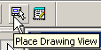
- Set the scale for the views as desired.
- Similarly place the other view.
- Save and close the drawing.

E. Updating the documents
- Right mouse on GA Drawings - Snapshot.
- Select Update Document(s)
- After a wait of about 1-2 min, the drawing is generated.

Drawings by Query Workflow
- Right-click on GA Drawings and select New…
- Add Component and from the General tab, select Drawing by Query Manager
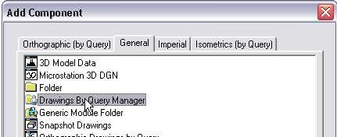
- Rename the newly added component to Pipe Support Drawings
- Right click on Pipe Support Drawings and Setup…
- Select values as below and click OK.
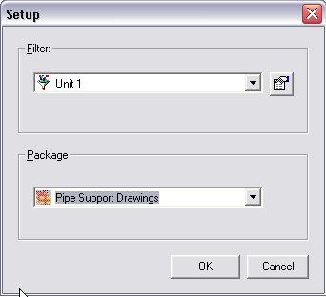
- Right-click on Pipe Support Drawings and Run Query. Wait till the tree is automatically created.
- Right-click on the lower Pipe Support Drawings node and Create Drawings
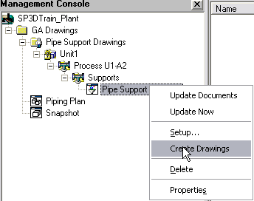
- Right-click and Update

Microstation 3D DGN Workflow
- Right-click on GA Drawings and select New..
- From the Add component dialog, select Microstation 3D DGN from the General tab
- Right-click on New 3D DGN Drawings and click Setup…
- Verify that the style is set to 3D DGN
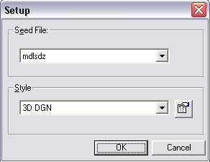
- Switch to the Space Management task
- Start the Place Drawing Volume by Selection command
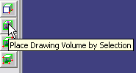
- On the ribbon bar, pick ‘New 3D DGN Drawings’ in the Drawing Type field and click OK.
- Select the slab, one of the top beams and one of the pumps as shown
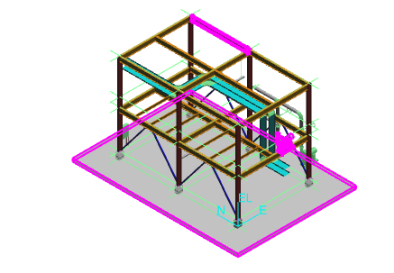
- Click Finish to create the volume
- Switch to Drawings and Reports task, create drawing and update. Wait while MicroStation is opened and closed.
- Double-click the drawing to open and view the output 3D DGN file.

3D Model Data (SmartPlant Review) Workflow
  - Right-click on GA Drawings, select New… and add a New 3D Model Data component from the General tab
  - Right-click on 3D Model Data and Setup…
  - Pick the Unit 1 filter and click OK.
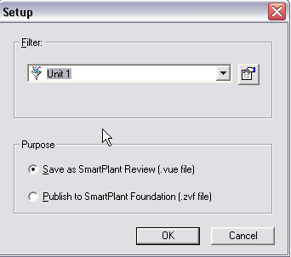
  - Create Drawing, a drawing named ‘Unit 1’ is created.
  - Update Now
  - Right-click on Unit 1 and Save as SmartPlant Review. Browse for the desired output location for the data and graphics files and supply a name, say Unit 1.
  - Double-click the Unit 1.vue file to open and review it in SmartPlant Review.

Setting Drawing Properties
Exercise:
- Select the Plant parent level in the hierarchy, right click, and select “Properties”. Add values for the following attributes;
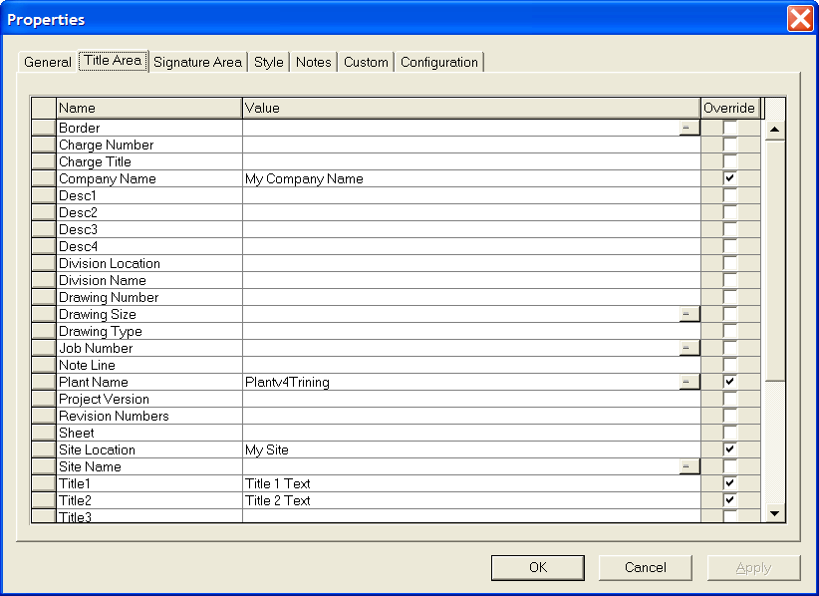
- OK the form to save the Plant level attributes.
- Right click on the “GA Drawings” folder, select “Properties” and review the attributes. Note that the Plant level attribute values have been applied to the GA Drawings folder.
- Edit the Title 2 text for GA Drawings properties to read ‘GA Drawings Level Data’
- OK the form and exit.
- Reselect the Plant root level, right click, and select “Properties”. Change the Title 1 attribute string to read “Plant Level Data”. OK and exit the form.
- Select the GA Drawings folder, right click, select “Properties”. Note that the Plant Level attribute for Title 1 has automatically changed to “Plant Level Data” in Drawings GA as changed above.
- Similar attribute behavior is seen for all plant folders, snap-ins, and items (drawings, reports, or isos).

Drawings Editor (SmartSketch) Basics

Where to find Drawings Editor inside SmartPlant 3D
Create a shortcut to the 2D drawings editor found in [Workstation Install Directory]\Common2D\Shape2D\Bin\Shape2Dserver.exe and put the shortcut in Start Menu – Programs – Intergraph SmartPlant 3D

Background and working sheets
- Every document has at least one working sheet and one or more background sheets.
- Any of the sheets can be designated as a background sheet for any of the working sheets.
- The background sheet for each working sheet can be chosen individually.
- You toggle between the two classes of sheets (background and working) using the View – Working sheets and View – Background sheets menu options.
- The origin of a sheet is at the lower left hand corner of a sheet.
- The origin can be accessed using File – Move Sheet Border command
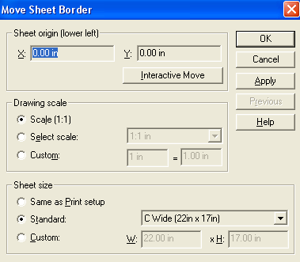

File – Properties – Units
- The units for readout in a sheet can be set using File – Properties – Units

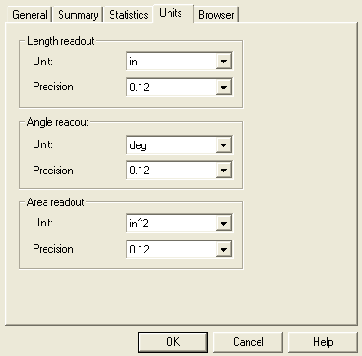

File – Sheet Setup
- The size and scale for a sheet is setup using File – Sheet Setup
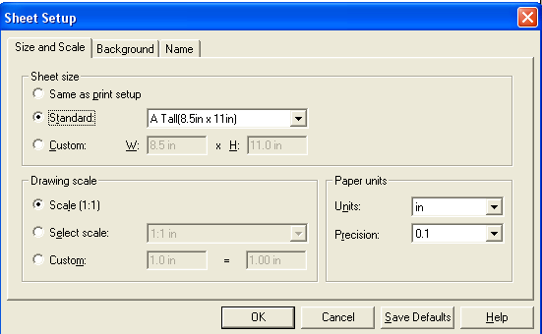
- The background sheet and whether to show it is chosen on the background tab
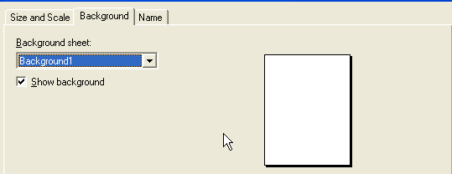

Print setup
- Once a printer is installed, the following settings may be made for printing using File – Print - Settings
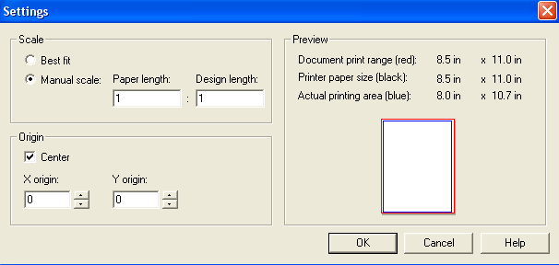
- The values chosen here will be a combination of paper size and sheet size. For example for a sheet size of C (22”x17”) and a paper size of A (11” x 8.5”), it is possible to select the Best Fit option and have it set automatically
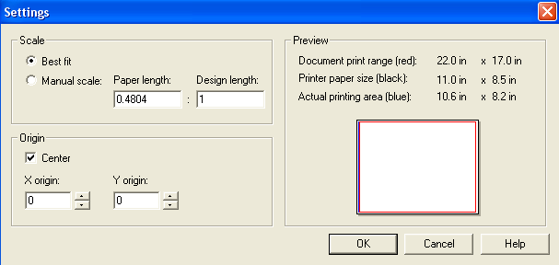
- Using the Tools – Options – View dialog, one can set the view to be displayed as printed. This thickens the lines based on printer resolution. This may result in a lesser detailed on screen display but one that is more like the printed version.

Pin point for accurate drawing
- For accurate drawing, the pin point toolbar may be used.
- The 2D and 3D pinpoints are very similar, allowing you to set the origin and step size.
- Once pin-point is started, it stays on until turned off
- When any drawing command (e.g. draw line) is used, values may be entered in pin point toolbar.

Relationships
- The relationships toolbar can be turned on or off using View – Toolbars – Check Relationship Box
- Relationships can be created between objects by selecting the relationship and selecting the two objects. E.g. to make two lines parallel, select the parallel button , then select the first line and the second line, the first line will change orientation to become parallel to second line
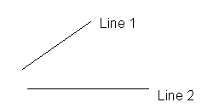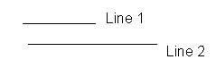
Before After
- If Maintain relationship is toggled on, the relationship created before is maintained (remembered)
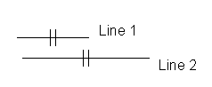

Format Line
- The Format – Line command may be used to change the color, width and style of a line
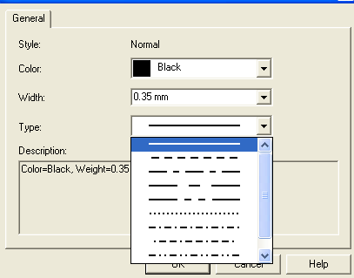
- The line style may be saved for future use by using the Format – Style (Style Type – Line) command
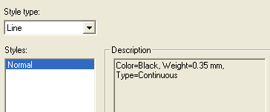

Format Dimension
- Dimensions may be formatted for various properties. General tab sets the color
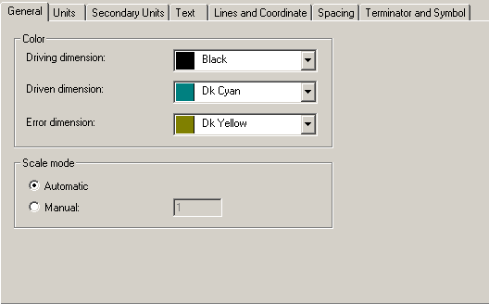
- Units and secondary units tab set the units
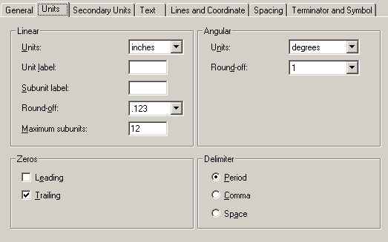
- Text/Lines/Spacing/Terminator options are also available.
- Similar to line style, all settings may be stored in Dimension Style
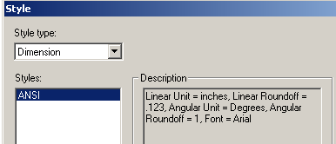

Layers
- Any number of layers can be created using Tools – Layers command.
- To create a new layer, type in its name in the Layers toolbar and press enter.
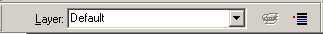
- Layer display can be turned on or off using Layer status 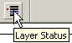 button.
- The bold layers are shown. The active layer is shown in red.
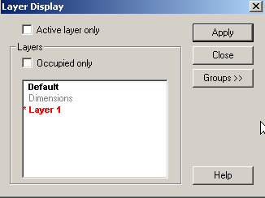
- The command to delete a layer is a custom command available in Common2d\Symbol2D\Client\Bin\CmdDeleteLayer.dll

Dimensioning
- The Dimensioning toolbar can be turned on or off using View – Toolbars – Check Dimension Box
- SmartDimension will automatically dimension the elements based on its type (length for linear, radius for arc etc)
- Distance Between command lets you pick two points or lines and finds coordinate distance between them
- Coordinate dimensions let you dimension successive elements from an initial point
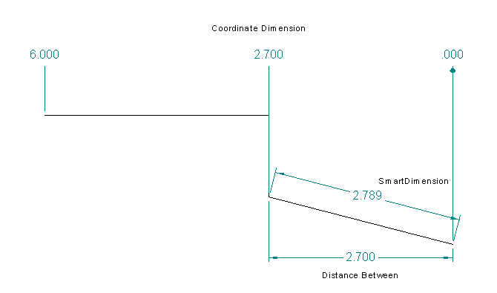

Detail view
- This command lets you expand out a portion of a drawing into a expanded blow up view
- Command is accessed using Insert – Detail View
- The scale and name for the view can be set
- The view can be placed on a different sheet than the parent element
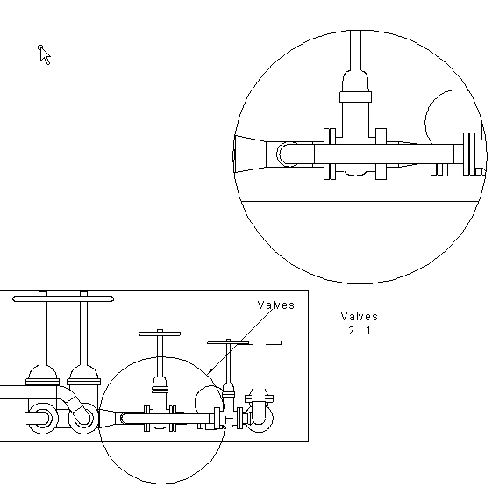

Align elements
- Elements can be aligned using the Align command on the change toolbar
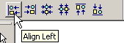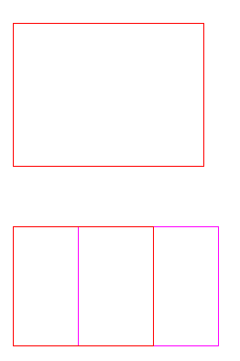

Symbol creation
- A symbol (cell) can be created out of selected elements.
- This can then be treated as one unit that can be placed.
- First draw the elements
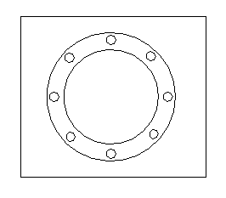
- Select the elements and press the create symbol button
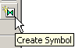
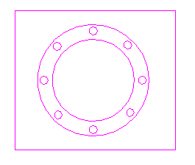
- Place the origin of the symbol where required and save the symbol as a file
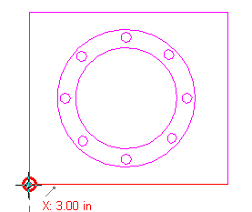

Exercise
- Create the following graphic in the Drawings Editor
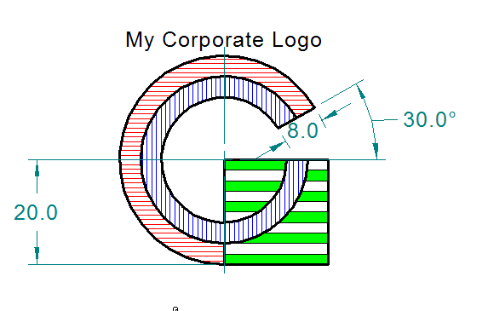
Note : Dimensions shown for reference, all in mm
Fill parameters as shown
Inner ring : Normal – Blue – 90 Degrees – 2.0 mm Spacing
Outer ring : Normal – Red – 0 Degrees – 2.0 mm Spacing
Horizontal Bars (these are hand drawn set of lines and not a fill pattern in the rectangle) – Solid - Green
- Save the graphic as a symbol file called “My_Symbol.sym”

Placing manual annotation

A. Manual labeling
  - Select the DrawingNumber1 from the Snapshot drawing type and Edit.
  - Zoom into the pumps in the plan view
  - Select the place a label command
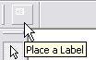
  - Select one of the pumps
  - From the pick list of labels, pick the Name_Rect_CA_JL label as shown
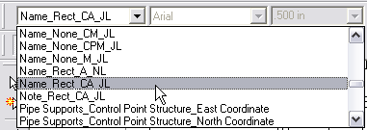
  - Make sure the ‘As Drawn’ checkbox in the ribbon bar is checked.
  - A label appears on your cursor, click in the sheet to place it where desired.
  - Now select the other pump and label it.
  - Right-click to exit the labeling command

B. Dimensioning
  - Click the Dimension button in the main toolbar to open the dimensioning toolbar.
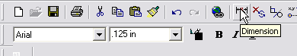
  - Dock the dimensioning toolbar to the top of the screen and select the Distance between command
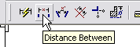
  - Select two gridlines in the plan view by clicking them in succession as shown. A dimension appears on your cursor.
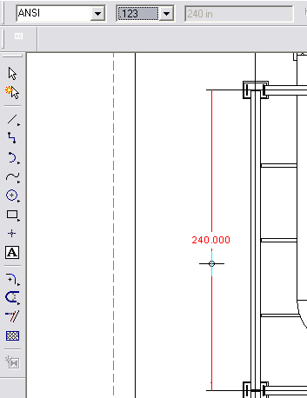
  - Click to place the dimension where desired.

C. User Text
  - Select Tools – Layers
  - In the layer toolbar, key in UserText and press Enter. This will create a new layer named UserText and make it active
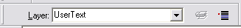
  - Using the text command on the vertical toolbar, enter some text, e.g. the name of the view and place it under the view.
  - Save and exit the drawing.

All of the manually placed text or graphic annotation on layers whose name starts with the letters ‘User’ is saved. All labels and dimensions are saved through updates.

Editing Border Templates

Creating New Template
- Open the Drawings Editor
- Select File => Properties => Units Tab. Set the file attributes as noted and select OK.
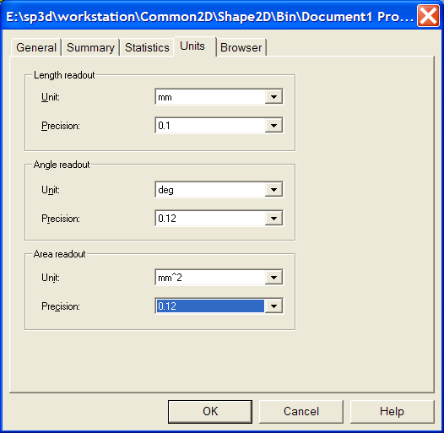
- Select File => Sheet Setup => Size and Scale tab. Set the file attributes as noted and select OK.
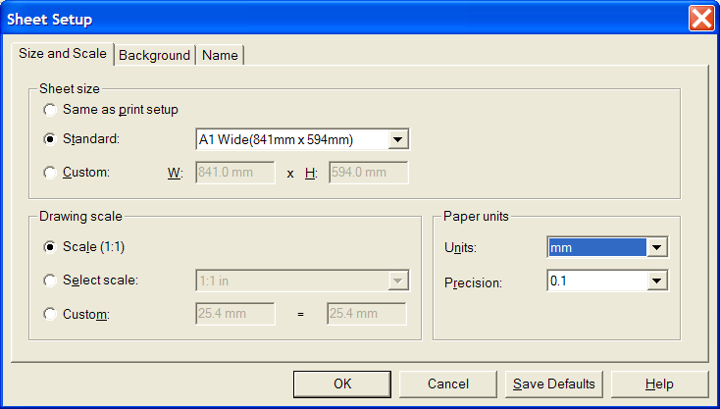
- Select File => Save as and save the file in the (\\[Symbol Share]\Drawings\Catalog\Templates) as “New_A1_1.sha” and select “Save”.
- Save the file again, but this time as “New_A1_2.sha”.

Using a DWG/DGN template to seed a drawing template
- First determine the size of the template file you want to create.
- Open Windows Explorer and navigate to [Installation Dir]\Common2D\Shape2D\Template
- Select Normal.sha and view File Properties and uncheck the Read Only attribute.
- Open Normal.sha in Drawing editor and set its size to the desired size of your template. Save and close drawing editor.
- Open Drawing Editor using desktop shortcut.
- File – Open to open the DGN or DWG file, the file contents are automatically converted to SHA format. Scaling issues are avoided due to steps 1 through 4.
- Tools – Layers and create a layer called ‘DwgTemplate’
- Select all border graphics from all auto-created layers in the file and move them to the DwgTemplate layer using the Change Layer button on the Layers toolbar.
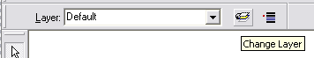
- Save the file in the [Symbol Share]\Drawings\Catalog\Templates directory with the desired name.

Using an Existing Template as a Background Sheet
- Open the New_A1_1.sha file.
- Select Insert => Object => Browse. Navigate to the existing A1_Wide.sha file in the Symbols\Drawings\Catalog\Templates directory and Select “Open” on the form.
- Uncheck the Link box and click OK.
- Place the file by pinpoint or concurrently by pressing the Escape key.
- Select Insert => Object
- The Insert Object form appears. Navigate to the My_Symbol file created earlier. Embed the company logo graphic as into the file
- Place the graphic in the border.
- Save the template file.
Note – In this example an existing Template was used as the border graphic. With this method of template creation users can select an existing border, edit existing borders, or create new borders as desired.

Adding Drawing Property Labels
- Enter the Drawings and Reports Task.
- Select Tools => Edit Border Template.
- Select “New_A1_2.sha” and OK the form.
- Select the Place Drawing Property Label command
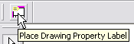
- In the Label Set pull down, pick Title Area
- In the Field pull down, pick CompanyName
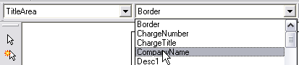
- Click close to the bottom right corner of the sheet to place the label
- Similarly pick the ApprovedBy field from the SignatureArea label set and place it as well.
- Save the template and exit Drawings Editor.

Basic View Styles

Creating a volume view style
- Tools → Define View Style
- In the View Style Type pick list, select Volume View Styles
- Click New to start creating a new view style.
- In View Style Name, enter Piping1 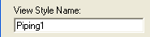
- In the first row of the grid, under Tests, under the Filter Name column, select More…
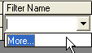
- Select the catalog filter under Catalog Filters\Default Filters\SP3D Object Filters\Object Types\Piping and select the filter named Piping Parts (not the folder with the same name).
- Under the Actions, under the Graphic Rule column, select More…
- Select New.
- In the Graphic rule – VHL dialog, set Rule Name: to Normal and Visible Line Style to Normal Red. Set description Visible:Normal Red.
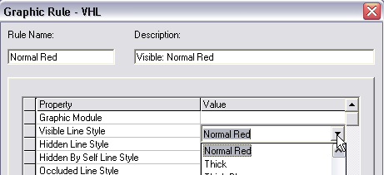
- Click OK to define the new VHL rule.
- Select Normal and click OK to apply the rule in the style.
- Under Matchline Label, select Matchline_None_A
- Click OK to define the view style.

Creating a snapshot view style
- Select Tools => Define View Style. Select “Snapshot View Style” from the pulldown on the form.
- Select “New”. The “View Style Properties - Snapshot” form appears.
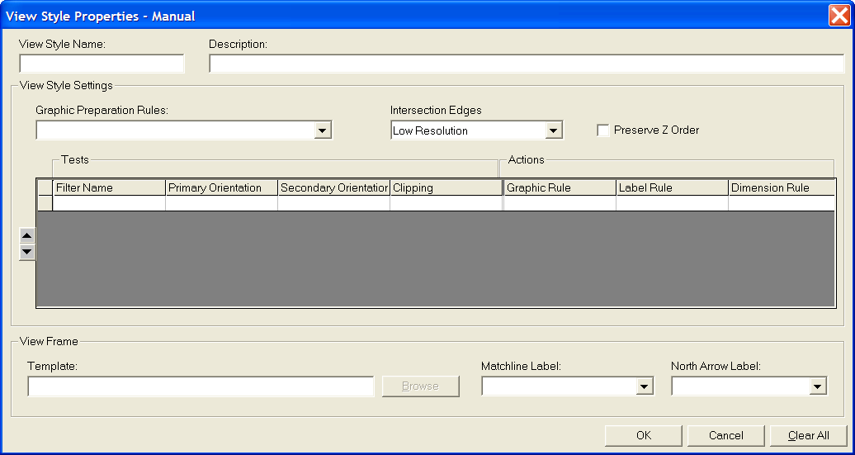
- Key in “Equipment1” for the View Style name and Description.
- Select the Filter Name => More… field. Select the catalog filter Catalog Filters\Default Filters\SP3D Object Filters\Object Types\Equipment and Furnishings and select the filter named Equipment.
- Select the Graphic Rule => More… field. The Select Rule form appears.
- Select the “Visible/Hidden Edges (VHL)” option from the pulldown list. And then Select “New”. The Graphic Rule VHL form appears.
- Key-in “Normal Blue” for the Rule name and Visible:Normal Blue for the Description.
- Select the “Visible Line Style” pulldown and select “Normal Blue”. OK the form.
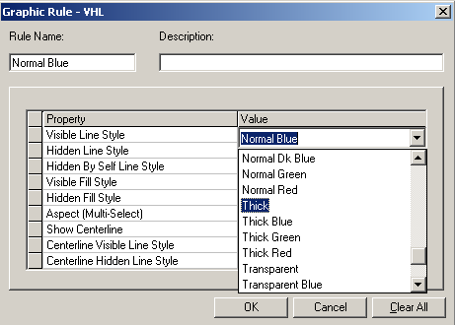
- Select the newly created graphic rule on the Select Rule form and OK the form.
- Similarly select Name_None_A_JL for the label rule.
- OK the form.
- You have now created a basic View Style for Snapshot Drawings.

Creating a key plan view style
  - Select Tools – Define Key Plan View Style
  - Select New… and name the view style ‘Plant view’
  - Select All Objects as the range filter
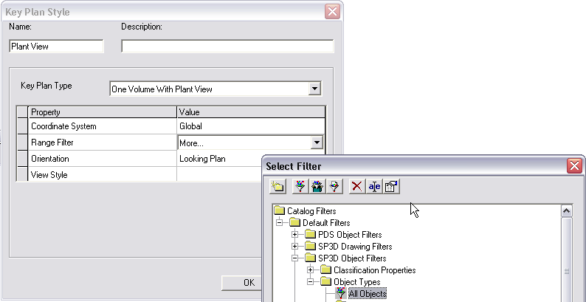
  - For the View Style, select More…
  - Switch to Volume View Styles and create a New View Style
  - Name it ‘Key Plan Plant View’
  - Select the filter for the first row to be ‘Grid Line’
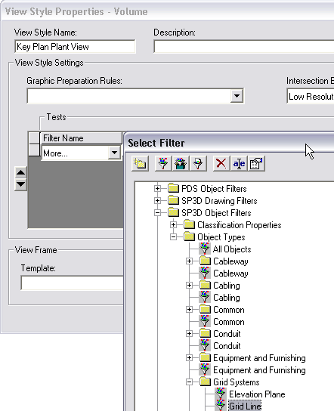
  - Select Normal Gray for the graphic rule
  - In the second row, enter ‘KEY_PLAN_FOCUS_ELEMENT’ in the filter column
  - Select Blue as a graphic rule

Creating a volume drawing package

A. Creating the package
  - Right-click on the plant and create a folder called Packages
  - Right-click on Packages and add a New Volume Drawings component
  - Rename New Volume Drawing to Piping1
  - Right-click on Piping1 and Edit Template
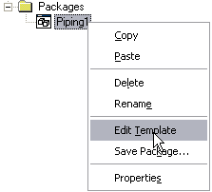
  - Select Imperial\D Wide Note Area and click OK.
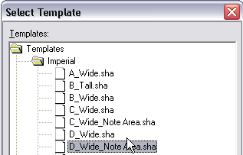
  - Maximize and fit the view in the Drawing Editor
  - Select the line at the top of the border till a quick pick is shown, using it select the symbol. Watch the attribute viewer on the right side of the Drawing Editor, it will show information when the symbol is selected.
  - Right-click on the symbol and select Single View
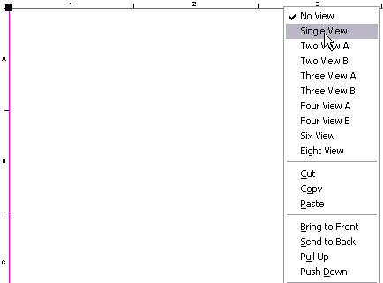
  - In the Attribute Viewer, set the Margin Offset to 3” and watch the view resize itself.
  - Use the Place Drawing view command to draw the 2D view coincident with the view shown.
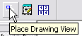
  - Fill in the Drawing View Properties as shown
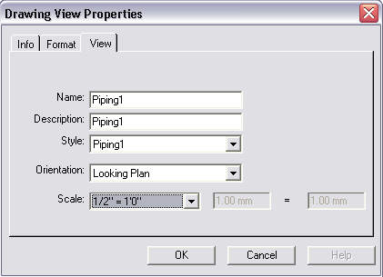
  - Switch to the Format tab and uncheck the Show Border box
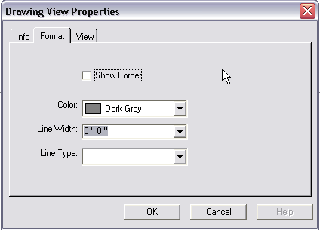
  - Now you may select the symbol (using quick pick) and delete it using the delete key. Its only function was to let you quickly place a correctly sized view.
  - Close the drawing editor and say Yes when prompted to save.
  - Right-click on Piping1 and Save Package…
  - Fill in values as below
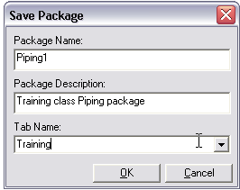
  - Now right-click the Piping1 package and delete it.

B. Testing the package
  - Right-click on GA Drawings and select New…
  - Notice that there is a new tab called Training in the Add Component dialog
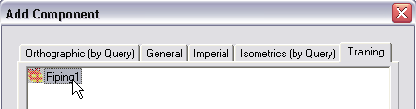
  - Select Piping1 and click OK.
  - Switch to Space Management task and clear view clipping
  - Start the place drawing volume by View command, make sure the ribbon bar shows the Piping1 drawing type selected.
  - Place the view where desired using pinpoint if necessary.
  - Switch to Drawings and Reports task
  - Create and update drawing. Observe that only piping parts that are inside the volume you placed are shown.

Defining Line Styles

- Open the file Styles.sha in the [Symbol Share]\Drawings\Catalog\Templates folder
- Format – Style and pick the Line option and click New
- Name the style Normal Dk Blue
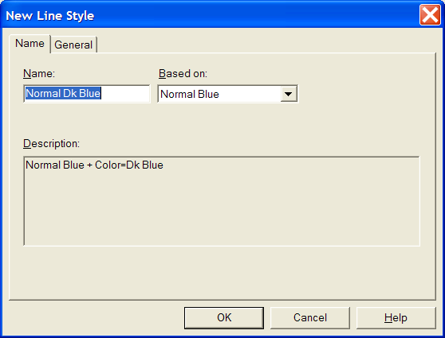
- Change the color to Dk Blue
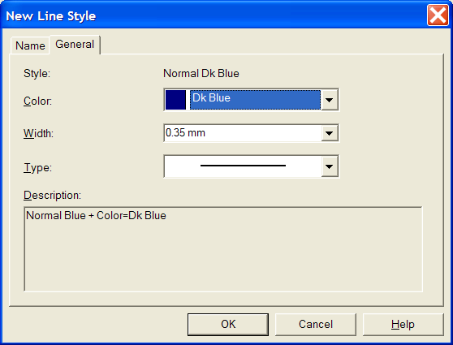
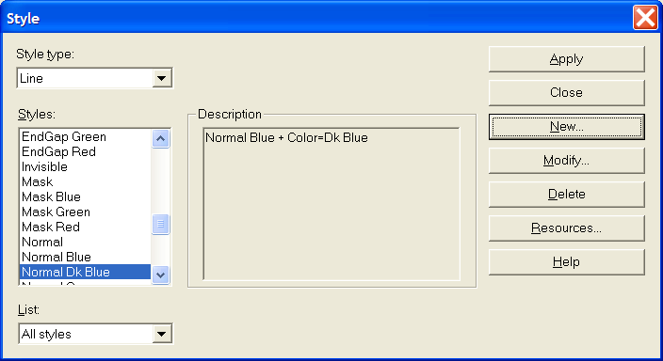
- Close and Save and Exit the Styles.sha file.

Graphic Rules

VHL Rule
VHL Rules simply replace the vector hidden line graphics with a line style chosen from the list of lines in Styles.sha
Define a VHL graphics rule for the Dk Blue line style created above
- Switch to the Drawings and Reports task
- Define View Style and choose the Snapshot View Style Equipment1
- In the Graphic Rule pulldown, select More…
- Click New to create a new graphics rule
- In the Visible Line Style pulldown, select Normal Dk Blue
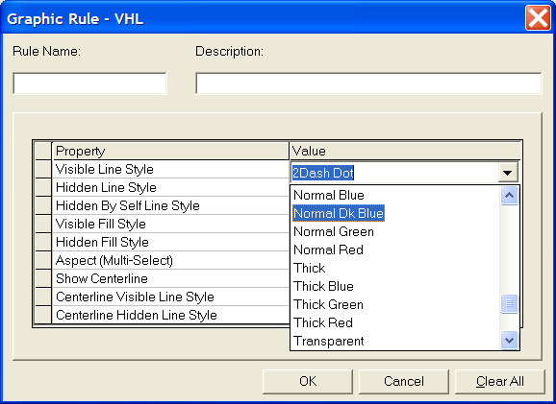
- Click OK to save the new VHL rule.
- Select Normal Dk Blue and click OK to apply it to the view style.
- Click OK to save the view style.
- Click OK to save the Rule.

Replace with Line Rule
This rule merely replaces the representation of the VHL graphics (linear segments) with a line.
- In the Graphic Rule field in the view style, select More…
- In the Graphic Rule type select Replace object with Line
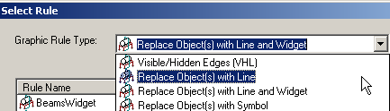
- Create a new Replace with Line Rule named RedLine
- In the Visible Line Style field, select Normal Red
- In the Hidden Line Style field select Dashed Red
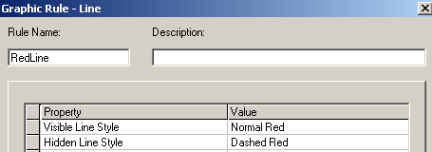
- Save the Rule

Replace with Line and Widget
This rule replaces the object with a line as above. Then it places a widget along the line to represent the cross section of the object. This widget can be either a VHL of the cross section or a externally created symbol.
- In the Graphic Rule type select Replace Objects(s) with Line and Widget
- Create a new Rule named BeamsWidget
- On the graphics tab, select visible line style to be Normal
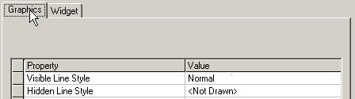
- On the widget tab, select values as below
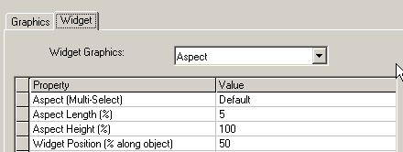
- Click OK to save the rule.

Replace object with symbol
We will create a symbol to use for the replace object with symbol rule first.
- Open the Drawings Editor
- Draw the graphic displayed below (do not include the dimensions). Use a line thickness of 1.0 mm and place it on the Default layer. It is not necessary to have Maintain Relationships set. 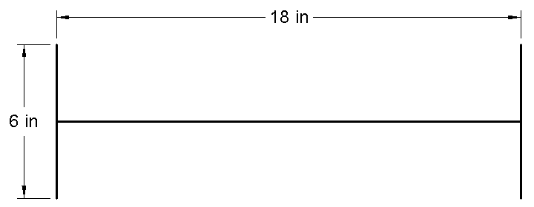
- Select the Select Tool command on the Draw toolbar and drag a fence around the graphics.
- Select the Create Symbol command.
- Left-click at the midpoint on the horizontal line to place the symbol origin. The Save As Symbol box appears.
- Browse to the Symbols share on the server and save the symbol to the [Symbol Share]\Drawings\Catalog\Symbols folder. Name the symbol “W18x35_X_Section”.
- Exit Shape2DServer without saving the document.
- Create a new Graphics rule of the type ‘Replace object with symbol’
- Name the rule Column
- Select the symbol “W18x35_X_Section”.
- Select OK on the Choose Symbol box.
We can now use this rule in a view style to select all columns and replace then with this symbol.

Defining Drawing Labels

Label Template
- Switch to the Catalog task
- Tools – Define Label
- Select the Labels folder and create a new folder named ‘Drawing Labels’
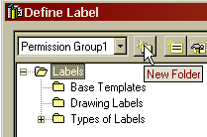
- Select the Drawing Labels folder and pick ‘New COM Label’
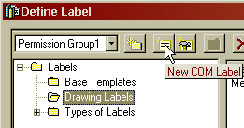
- Name the Label MemberType by typing in the name in the Name field
- Add a property ‘Type’ to the label from the Member Part Prismatic
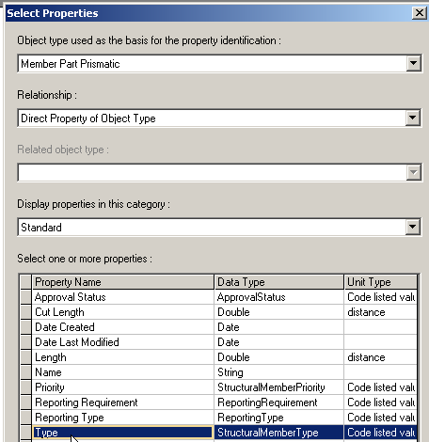
- Select the Type property and insert it to the layout 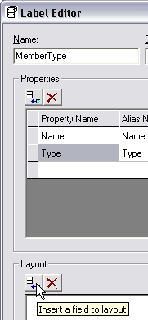
- Similarly insert the Name property
- Click OK to save the label.
- Using Windows Explorer, browse to [Symbols Share]\Labels\Drawing Labels\MemberType and copy all the files.
- Browse to [Symbols Share]\Drawings\Catalog\Labels\Templates and paste the files.

Label Symbol File
- Using Windows Explorer, navigate to the [Symbols Share]\Drawings\Catalog\Labels\Templates folder.
- Copy the SectionSize_None_APO-NL.sym and SectionSize_None_APO-NL.xml files and paste them in the same directory
- Rename them to MemberType.sym and MemberType.xml
- Double-click MemberType.sym to open it
- Double-click the word SectionSize till it highlights in yellow background and then type word MemberType. (This is for your information only, software does not care what text you put here.)
- Right-click the word MemberType and select Properties
- You can change the Border and fill attributes as desired, e.g. choose Border color as Dk Blue and Fill color as Yellow.
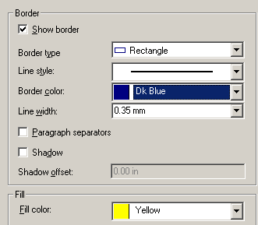
- In the User tab, change Value to MemberType
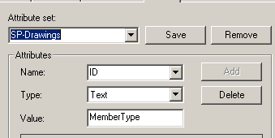
- Click OK and then save the symbol and exit.

Label XML File
- Open the MemberType.xml using NotePad, CookTop or other text editor.
- Scroll down to line 84
<ID attributeName="SectionSize">SectionSize.rtp</ID>
- Change SectionSize to MemberType and SectionSize.rtp to MemberType.rtp
- Edit one of the drawings that contains a Structural Member.
- Start the manually place label command
- Select a structural member.
- Select MemberType from the list of labels
- Click to place

These are the settings that can be set for a label in the XML file:

Name of the label
Name of the label template file and attribute set on the label sym text box
Positioning rules for the label

A | Absolute X and Y location relative to an object.
APO | Absolute X and Y location, parallel, and offset relative to an object.
AV | Absolute X and Y location relative to a vector from the center of the view, and aligned to the object.
CA | Positioned in Clear space by quadrant priority, or positioned in an Absolute X and Y location relative to an object if no clear space is found.
CP | Positioned in Clear space and aligned Linear to the coordinate system.
CM | in the Margin if no clear space is found.
M | Positioned outside the view in the Margin.

Leader placement rule
L | Leader with no jog
JL | Jogged Leader
NL | No Leader

Creating Label Rule
- Copy \Catalog\Rules\LabelRules\SectionSize_None_APO_NL.xml.
- Paste and rename it as MemberType.xml
- Open the file and change SectionSize_None_APO_NL to MemberType. Now the new label is available as a rule

Custom Graphic Rules
These rules are used to change the 3D geometry that is passed into the VHL routines.

CappedNormalPipe.dll

Applies to: Straight pipe, normal to the view
What it does: Replaces the pipes normal to the view with a cylindrical cap in the center of the length of the pipe
When to use: If open (unclipped) ends of pipe are to be replaced with a symbol

DesignEquipmentPartSeparator.dll

Applies to: Equipment
What it does: Separates equipment into body (first shape placed), shapes, nozzles and parts (child components).
When to use: To label and symbolize nozzles of equipment
How to use: In Graphic Preparation Rules, define a rule that uses Equipment as the filter and apply the DesignEquipmentPartSeparator.dll to it. Once this is done, you may put a row for Pipe Nozzles in the view style.

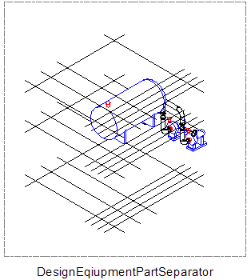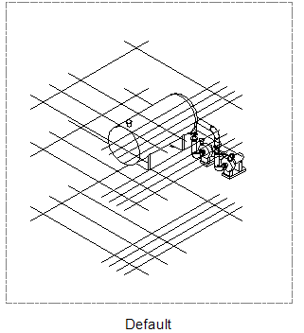

ElbowtoArc.dll

Applies to: Piping Elbows
What it does: Replaces 3D elbow with an arc for the body and two discs for the two ports
When to use: When piping elbows are to be represented as single line but the ends of piping are to be shown.
How to use: In Graphic Preparation Rules, define a rule that select piping components and apply the ElbowtoArc.dll to it.

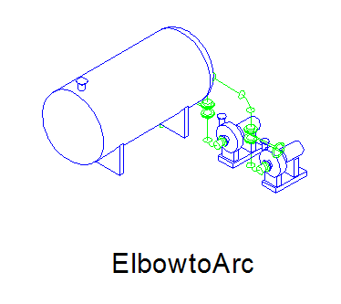

ElbowtoSingleArc.dll

Applies to: Piping Elbows
What it does: Replaces 3D elbow with an arc
When to use: When piping elbows are to be represented as single line
How to use: In Graphic Preparation Rules, define a rule that select piping components and apply the ElbowtoSingleArc.dll to it.

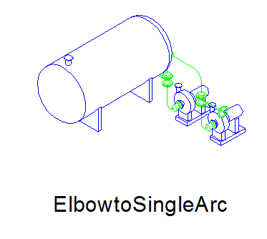

EquipmentNozzleSeparator.dll

Same as DesignEquipmentPartSeparator, but for standard equipment.

GridlinesDrawingWrapperEntity.dll

Applies to: Grid Planes
What it does: Draws ‘vertical gridlines’ at the intersection of X planes and Y planes (on the X-Z and Y-Z axes)
When to use: In elevation and isometric views when drawings need to show vertical lines at grid intersections
How to use: In Graphic Preparation Rules, define a rule that uses GridPlanes as the filter and apply the Gridlines DrawingWrapperEntity.dll to it. Once this is done, you may put a row for Grid Planes in the view style. The graphic rule for the grid planes also needs to include a reference to the GridlinesDrawingWrapperEntity.dll.

MakeDrawable.dll

Applies to: All graphical objects
What it does: Makes objects that are usually not displayable in 3D (hence not drawable in 2D), drawable.
When to use: Whenever you need to label or display objects such as features, runs, systems, pipe support assemblies on a drawing.
How to use: In Graphic Preparation Rules, define a rule that select the objects that are to be made drawable and apply MakeDrawable.dll to them
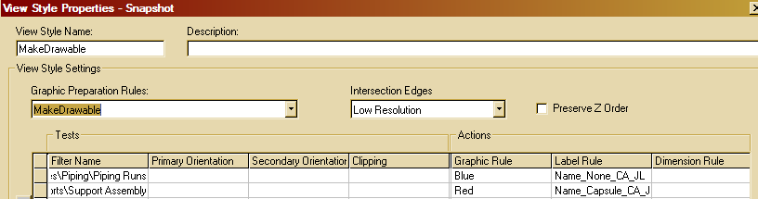

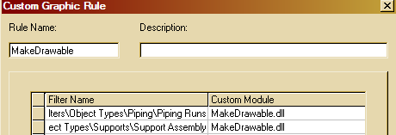

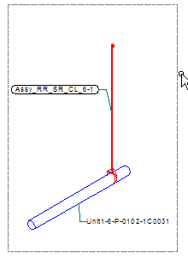

PipeTurnFeattoArc.dll

Applies to: Piping turn features
What it does: Makes the piping turn feature drawable and replaces it with a single arc
When to use: When pipe bends are to be shown as single line.
How to use: In Graphic Preparation Rules, define a rule that select piping turn features and apply the PipeTurnFeattoArc.dll to it.

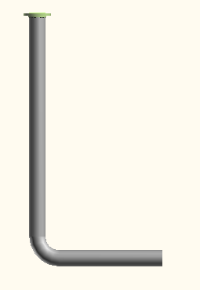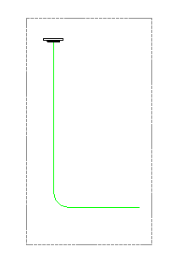

PortsSeparator.dll

Applies to: Piping components
What it does: Separates the ports of the piping components from the component and makes them drawable
When to use: When the open end of an elbow is to be replaced by a symbol
How to use: In Graphic Preparation Rules, define a rule that select piping components and apply PortsSeparator.dll to them. Then in the view styles, use the PsuedoFilter ‘Ports’ as FilterName::Ports and replace with symbol graphic rule.

ReplaceWPoint.dll

Applies to: All graphical objects
What it does: Replaces the 3D geometry of the object with a tiny sphere at the center of the range
When to use: When you need to label an object but do not wish for it to participate in VHL and potentially hide other objects behind it.
How to use: In Graphic Preparation Rules, define a rule that select the objects that are to be replaced with a point and apply ReplaceWPoint.dll to them

SlopedPipeWArcSymbol.dll

Applies to: Sloped straight pipe
What it does: Replaces straight pipe with its centerline and a series of arcs representing the slope
When to use: When sloped pipe is to be represented on a plan drawing

VolumeWireFrame.dll

Applies to: All graphic objects
What it does: Replaces an object with its wireframe representation for VHL
When to use: When you need to show outlines of certain objects and want to keep the objects’ surfaces from hiding other objects
How to use: In Graphic Preparation Rules, define a rule that selects the objects and apply VolumeWireFrame.dll to them.

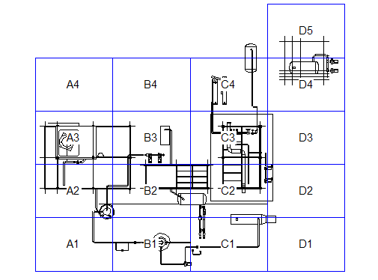

Advanced View Styles
The basic view style consists of several rows each with a filter and a graphic rule. This determines what goes on a drawing and how it looks. Adding labels to the view style can be considered an intermediate operation. The advanced operations consist of additional orientation and clipping tests, custom graphic rules and dimensioning rules.

Deconstructing the piping plan view style
The instructor will lead you through opening a Piping Plan drawing created with the delivered Piping Plan view style and identifying what elements on the drawing are created by which rows in the view style.

Analysis of drawings for view style creation
The following table describes the set of steps required to create a view style to match a drawing standard.

Analysis | SP3D Activity | UI
Read paper drawing to identify items included | Map objects seen on drawing to SP3D object types and match up each kind with a specific filter | Filter UI. May have to rely on SQL filters for certain kinds of elements.
Find out graphical representation in drawing (single line/double line, line style, weight, color etc and all the conditions that prompt that line style to be used). | Decide which graphic rule is to be used for each of the objects identified above. Objects may have to be subclassified based on size, orientation w.r.t paper, clipping conditions etc.  It may be required to use custom graphic wrappers to change the 3D representation of objects to suit the drawing requirements. | Graphic rule UI.  UI exists for creating new line styles.
Find out label annotation required for each and the rules to place the annotation (data reported by the label, position of the label w.r.t the object, leader lines - their styles etc). | Decide what object is labeled with what data and where the data is in the data model. A report label that traverses the relationships will need to be written if required.  Decide which point on the object needs to be labeled (end, center, control point, origin etc).  Decide which positioning modules are appropriate for each label (absolute, parallel, clearspace, margin)  Decide which leader modules are to be used. | UI exists for writing the report label and the look and feel of the label in the sym file.  There is no UI yet for the positioning and leader portions.
Find out dimensioning required for each item type. Dimensioning includes dimension attributes such as units, arrow style etc as well as its position w.r.t object. Since dimensions are always between two things (either parts of the same object or distinct objects), find out how each dimension was placed and what it represents. Dimensions are best of thought of as chains composed of various object types, with some anchoring types (e.g. columns, grids or decks) and other target object types (e.g. equipment, piping etc). | Decide the type of dimension  (only linear currently supported except for penetration plates)  Decide what point of the object the dimension witness lines need to reach.  Decide which positioning modules are appropriate (absolute, clear space, margin)  Decide the direction of the dimension (horizontal, vertical)  Define anchoring elements filters and target element filters. | No UI.

